**Business problem**

Create a model that tells what are the variables that influenced a person to buy or not a car after being exposed to an add on a social network.

**Explaining the model**

1. Import the dataset, which is in a csv format.
2. We need to get rid of the columns that we won’t look at (gender and ID), so we need to subset the dataset.
3. For this specific model, we need to set our dependent variable as a factor, to be able to use the predictor in the matrix later.
4. After that, we will split the dataset into a training and test set (a 75% do the training set will be enough, as our dataset has 400 entries in total).
5. Before creating the classifier, we need to put all values on the same scale (after the sub-setting, the columns have new indexes).
6. After creating the classifier, we create the predictions. The first argument is the dataset except the dependent variable, the second is the dependent variable.

**Plotting the results**

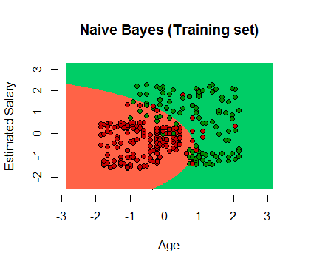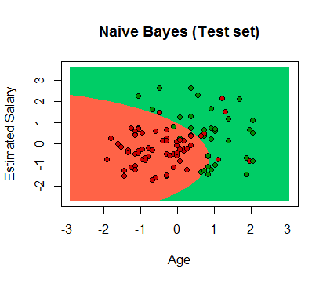

**Evaluating the model’s performance**

The confusing matrix allows us to compare the right vs wrong predictions.



As we can see, we got a total of 86 correct predictions (86%) and 14 wrong predictions (14%), from which 7 are false positives (type I) and 7 are false negatives (type II).